Name: Mahmoud Essam Mahmoud Ali

BN: 853

Date: 30/5/2020

Code: ECE001

Topic: Big data

Github link:

Github pages:

Why I choose this topic: because I was wondering where data from well-known sites and applications like facebook, Instagram and Microsoft is stored

Applications: Big data has found many applications in various fields today. The major fields where big data is being used are as follows.

**1-Government**: Big data analytics has proven to be very useful in the government sector. Big data analysis played a large role in Barack Obama’s successful 2012 re-election campaign. Also most recently, Big data analysis was majorly responsible for the BJP and its allies to win a highly successful Indian General Election 2014. The Indian Government utilizes numerous techniques to ascertain how the Indian electorate is responding to government action, as well as ideas for policy augmentation.

**2-Social Media Analytics:** The advent of social media has led to an outburst of big data. Various solutions have been built in order to analyze social media activity like IBM’s Cognos Consumer Insights, a point solution running on IBM’s BigInsights Big Data platform, can make sense of the chatter. Social media can provide valuable real-time insights into how the market is responding to products and campaigns. With the help of these insights, the companies can adjust their pricing, promotion, and campaign placements accordingly. Before utilizing the big data there needs to be some preprocessing to be done on the big data in order to derive some intelligent and valuable results. Thus to know the consumer mindset the application of intelligent decisions derived from big data is necessary.

**3-Technology:** The technological applications of big data comprise of the following companies which deal with huge amounts of data every day and put them to use for business decisions as well. For example, eBay.com uses two data warehouses at 7.5 petabytes and 40PB as well as a 40PB Hadoop cluster for search, consumer recommendations, and merchandising. Inside eBay‟s 90PB data warehouse. Amazon.com handles millions of back-end operations every day, as well as queries from more than half a million third-party sellers. The core technology that keeps Amazon running is Linux-based and as of 2005, they had the world’s three largest Linux databases, with capacities of 7.8 TB, 18.5 TB, and 24.7 TB. Facebook handles 50 billion photos from its user base. Windermere Real Estate uses anonymous GPS signals from nearly 100 million drivers to help new home buyers determine their typical drive times to and from work throughout various times of the day.

**3-Fraud detection:** For businesses whose operations involve any type of claims or transaction processing, fraud detection is one of the most compelling Big Data application examples. Historically, fraud detection on the fly has proven an elusive goal. In most cases, fraud is discovered long after the fact, at which point the damage has been done and all that’s left is to minimize the harm and adjust policies to prevent it from happening again. Big Data platforms that can analyze claims and transactions in real time, identifying large-scale patterns across many transactions or detecting anomalous behavior from an individual user, can change the fraud detection game.

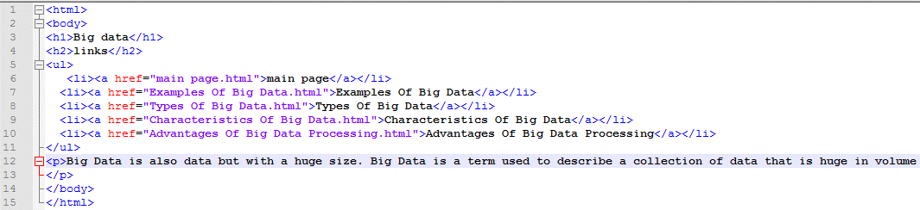References: <https://www.digitalvidya.com/blog/big-data-applications/>

Source code:

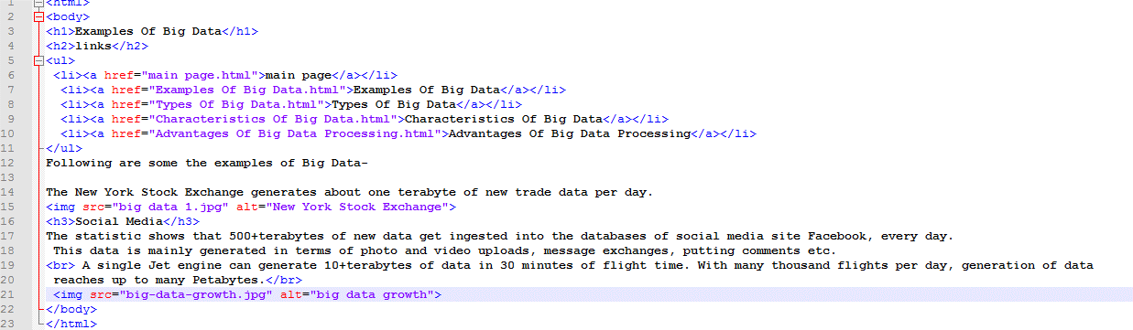

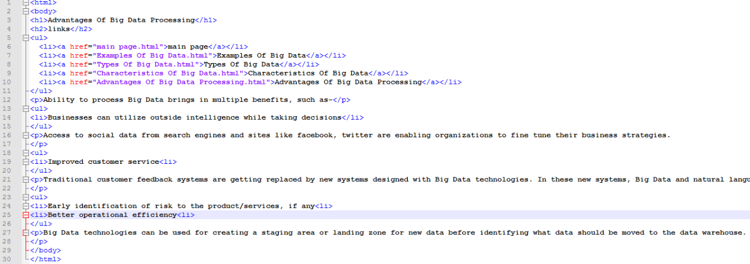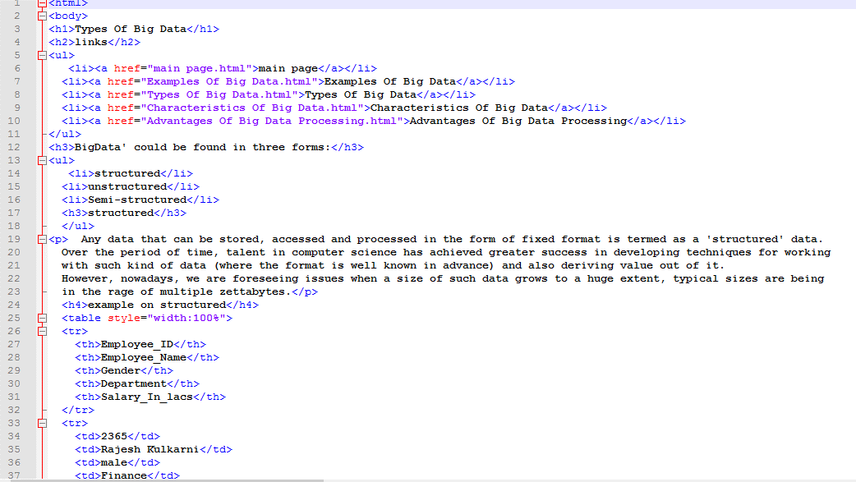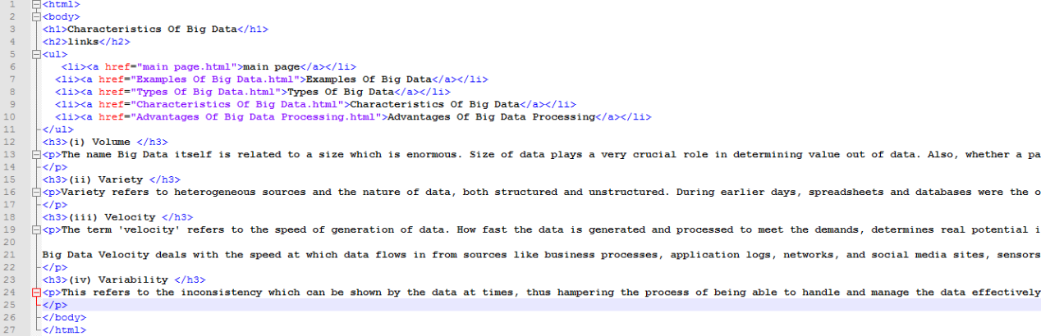

Screenshots: 